MAINTAINCE SHEET FOR GC-NET v3
Station name: | CP1 |  | Date: | 08-05-2026
People present: | RSF, HETJA, IASTE, ARU |  | Maintenance |  | Install | Take-down | Data Download

Weather: | Sunny, high clouds

METADATA
 | Arrival | Departure
Download Data | YES / NO | NA
Time difference between logger and UTC (± mm:ss) | : | 0:0
Screenshot of ‘Status’ table | YES / NO | YES / NO
Screenshot of ‘Public’ table in FastScan mode | YES / NO | YES / NO
Photos of mast, loggerbox and sensors (inc. radiometer serial) | YES / NO | YES / NO

STATION POSITON AND OREINTATION
 |  |  | Arrival |  | Departure
Lower lufft height (see A) |  |  | 305 cm |  | 305 cm
Lower SR50 height (see A) |  |  | 285 cm |  | 285 cm
Upper lufft height (see A) |  |  | 430 cm |  | 430 cm
Upper SR50 height (see A) |  |  | 410 cm |  | 410 cm
Upper boom direction (towards radiometer, see B) |  |  | 342 degree mag. |  | 342 degree mag.
Lower boom direction (towards lufft, see B) |  |  | 252 degree mag. |  | 252 degree mag.
Upper wind sensor orientation (away from black box, see C) |  |  | Yes |  | Yes
Lower wind sensor orientation (away from black box, see C) |  |  | Yes |  | Yes
Radiometer across-boom tilt, looking at the front (see D) |  |  | 2 degrees to east/right |  | 0 degree
Mast tilt north-south axis |  |  | 2.5 degree down-south |  | 2.5 degree down-south
Mast tilt east-west axis |  |  | 2 degree to right/east |  | 2 degree to right/east
Height of thermistor string pipe above surface |  |  | 157 cm |  | 157 cm
Depth of snowboard | 125 cm | Height of snowboard stake |  | 42 cm Vertical: YES / NO
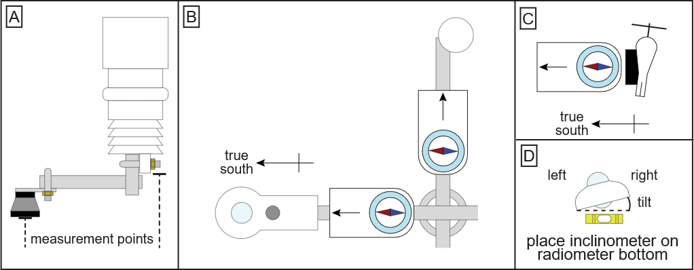

Station name: | CP1 |  | Date: | 08-05-2026
STATION HARDWARE
To do? | Done? | Item | Comments
Update program | yes | Loggerbox | ID arrival: M3 – 08  ID departure: M3-08
 |  | Modem IMEI | IMEI arrival: 300534062024750  IMEI departure: 300534062024750
Replace | Yes | Radiometer | Serial arrival: 213256  Serial departure: 244249
 |  | Wind sensor upper | Type arrival: Black / White  Type departure: Black / White
 |  | Wind sensor lower | Type arrival: Black / White  Type departure: Black / White
Replace | Yes | Lufft upper
Replace | Yes | Lufft lower
Replace | No | SR50 upper | Reused old sensor
Replace | Yes | SR50 lower
Replace | Yes | Thermistor string | Installed new/old thermistor string
 |  | Iridium antenna
 |  | Solar panel
Replace | Yes | Battery box | Burial under lower lufft: YES / NO  Location if NO:
Replace | no | Mast | No need

NOTES (e.g. sensor damage, must-do at next visit)
We had no extension cable for thermistor, so we installed a new in the old tube. Tube was not extended because cable was too short. Bamboo stick and carbonfiber stake marks the top of the thermistor tube. FOR NEXT YEAR: THERMISTOR STRING INSIDE TUBE CANNOT BE EXTENDED, SO IT MUST BE REPLACED.
New snowboard installed.
Liquidice GNSS installed.
Loggerprogram updated to GCNET v2.7

